**Experiment no. 11**

**Name: Sonali Dattatray Kaingade**

**PRN: 21620002**

**Title:** Write a program for Agglomerative Hierarchical clustering using single linkage method

**code:**

#include <bits/stdc++.h>

using namespace std;

int op = 1;

ofstream fwtr("linkage_output.csv", ios::out);

// Function to perform agglomerative clustering and return the name of the resulting cluster

string agglomerative(string input)

{

map<string, map<string, int>> dm;

fstream file(input, ios::in);

string line;

getline(file, line);

int pt = 0;

stringstream st(line);

int i = 0;

string point;

vector<string> points;

// Read the point names from the first line of the input file

while (getline(st, point, ','))

{

if (i == 0)

{

i++;

continue;

}

points.push_back(point);

}

// Populate the distance matrix from the input file

while (getline(file, line))

{

stringstream str(line);

getline(str, point, ',');

string dist;

int idx = 0;

while (getline(str, dist, ','))

{

if (dist.length() != 0)

dm[point][points[idx]] = stoi(dist);

idx++;

}

}

string pt1, pt2;

int min_dist = INT_MAX;

// Find the two points with the minimum distance

for (auto p : dm)

{

for (auto pp : p.second)

{

string p1 = p.first, p2 = pp.first;

int dist = pp.second;

if (p1 != p2 && dist < min_dist)

{

pt1 = p1;

pt2 = p2;

min_dist = dist;

}

}

}

cout << "Clusters Chosen: " << pt1 << " & " << pt2 << endl;

string up, down;

// Determine the order of the two points based on their names

if (pt1[0] > pt2[0])

{

up = pt2;

down = pt1;

}

else

{

up = pt1;

down = pt2;

}

string newPt = down + up;

// Update distances and remove old points from the matrix

for (auto p : dm)

{

point = p.first;

if (point[0] > newPt[0])

{

dm[point][newPt] = min(dm[point][up], dm[point][down]);

}

}

for (auto p : dm[down])

{

point = p.first;

int d1 = p.second;

if (point[0] < up[0])

d1 = min(d1, dm[up][point]);

else

d1 = min(d1, dm[point][up]);

dm[newPt][point] = d1;

}

for (auto p : dm)

{

point = p.first;

auto mtemp = p.second;

if (point[0] >= up[0])

{

int d1 = dm[point][up];

if (down[0] > point[0])

d1 = min(d1, dm[down][point]);

else

d1 = min(d1, dm[point][down]);

dm[point][newPt] = d1;

dm[point].erase(up);

if (point[0] >= down[0])

dm[point].erase(down);

}

}

dm.erase(up);

dm.erase(down);

// Create an output file with updated cluster data

string output = "output" + to_string(op++) + ".csv";

ofstream fw(output, ios::out);

fw << ",";

for (auto p : dm)

{

fw << p.first << ",";

}

fw << "\n";

for (auto p : dm)

{

fw << p.first << ",";

for (auto pp : p.second)

{

fw << pp.second << ",";

}

fw << "\n";

}

fw.close();

fwtr << down << " & " << up << "\n";

return output;

}

int main()

{

string input = "linkage_input.csv";

fstream file1(input, ios::in);

string line;

getline(file1, line);

int pt = 0;

stringstream st(line);

int j = 0, len = 0;

string point;

// Determine the number of points in the dataset

while (getline(st, point, ','))

{

if (j == 0)

{

j++;

continue;

}

len++;

}

// Repeatedly perform agglomerative clustering to create clusters

for (int i = 1; i <= len - 2; i++)

{

string output = agglomerative(input);

input = output;

}

return 0;

}

**Result:**

**Input.csv:**

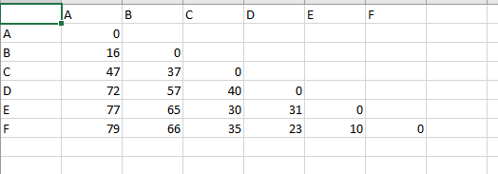

**Output.csv:**

**1.**

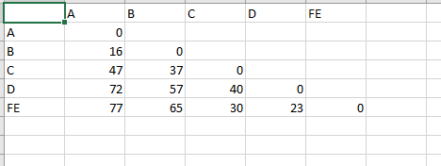

**2.**

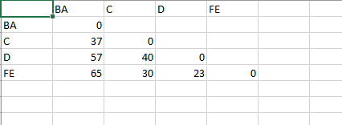

**3.**

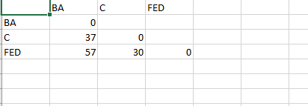

**4.**

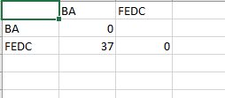

**final output:**

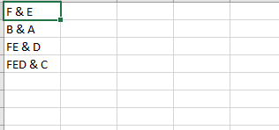

**knime:**

